**CS 155 Project 3 Robot**

Xiaotian Wang / Amanda Yin

1. Feature implemented

|  |  |  |
| --- | --- | --- |
| **Part I (30 points)** | | |
| **If Completed** | **Function Name** | **Points** |
| Y | Build a 3D world with a tiled floor and three 3D objects. | 5 |
| Y | Add ambient light as well as a point light. The point light should have noticeable attenuation across the tiled floor. All objects should be lit and at least one should be shiny. | 5 |
| Y | Add menus that allow the user to toggle on and off ambient lighting and (independently) the point light. | 5 |
| Y | Build camera controls that allow the user to reposition and reorient the camera easily. Also include a zoom feature. To receive full credit your controls should be intuitive and easy to use!! | 10 |
| Y | Implement a help menu that explains the camera controls. | 5 |
|  |  |  |
| **Part II (35 points)** | | |
| Y | The robot should have a head that turns and nods. | 4 |
| Y | The robot should have a spot light on its head (like a miner's lamp) that can be toggled on and off. (Note: When the robot moves its head, its spot light should visibly move in the scene.) | 5 |
| Y | The robot should have at least one arm that rotates at the wrist, elbow, and shoulder (or some equivalent depending on physiology). | 5 |
| Y | The robot should have a body that can move around the floor. | 4 |
| Y | The user should be able to toggle the camera control to see the world from the robot's perspective. | 10 |
| Y | Add information on robot control to your help feature. | 2 |
| Y | Additional feature to help improve robot control. | 5 |
|  |  |  |
| **Part III: Bells and Whistles** | | |
| Y | Build a simple roller coaster using a catmul-rom spline for the rails. (You should specify the control points in your code but sample and draw the curve in real time.) The user should be able to take a ride; i.e. move the camera along the rails (with toward and up specified by the tangent and normal to the curve) at realistic speeds. | 10 |
| Y | Make the robot do a cool robot trick and capture it in an mpeg movie. The trick also should be accessible from the menu. An exceptional trick may garner extra points. (Only one lame trick will get credit!) | 5 |
| Y | Add shadows using the projection method with polygon offset. | 5 |
| Y | Add reflections using the stencil buffer to prevent reflection beyond the floor. | 5 |
| Y | Add texture mapping. | 5 |
| N | Add bump mapping using a shader. | 10 |
| N | Create a portal using clipping planes. The portal should be represented graphically in some way, e.g. as two doorways. | 5 |
| Y | Add a mirror (the floor does not count!). (Be sure to consider the possible viewpoints; i.e. the robot can look in the mirror and see itself.) | 5 |
| Y | Add a billboarded object. | 5 |
| Y | Add fog effects. | 5 |
| ? | Win the best robot contest. | 5 |
| ? | Win the best robot trick contest. | 5 |
| Y | Impress us with something we hadn't considered.  Fonts and Buttons | ? |

1. Completed parts
2. 3D world and 3D objects

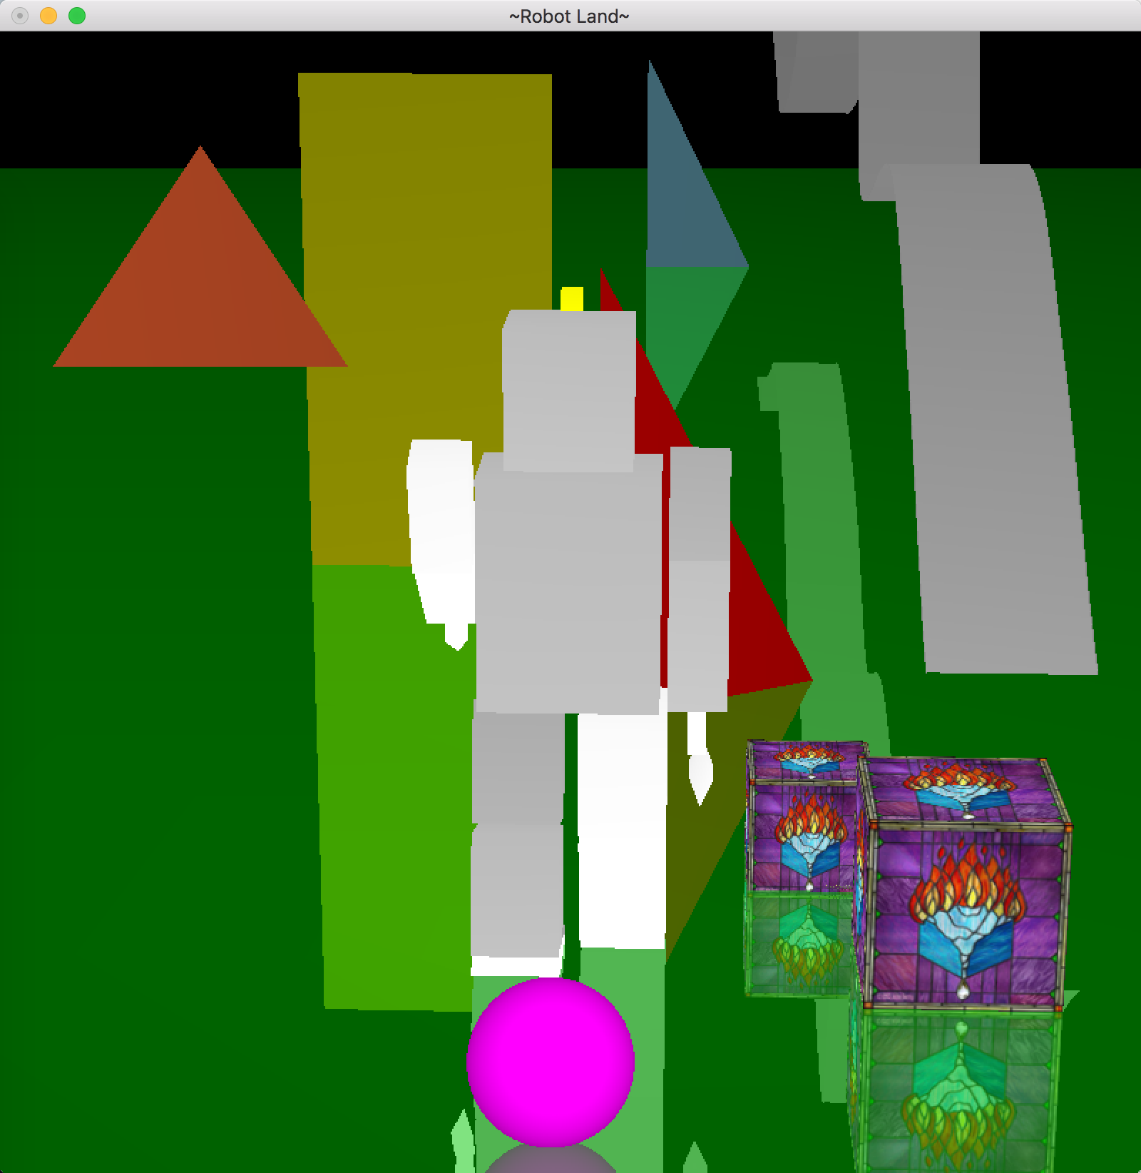

1. Ambient light, point light and attenuation

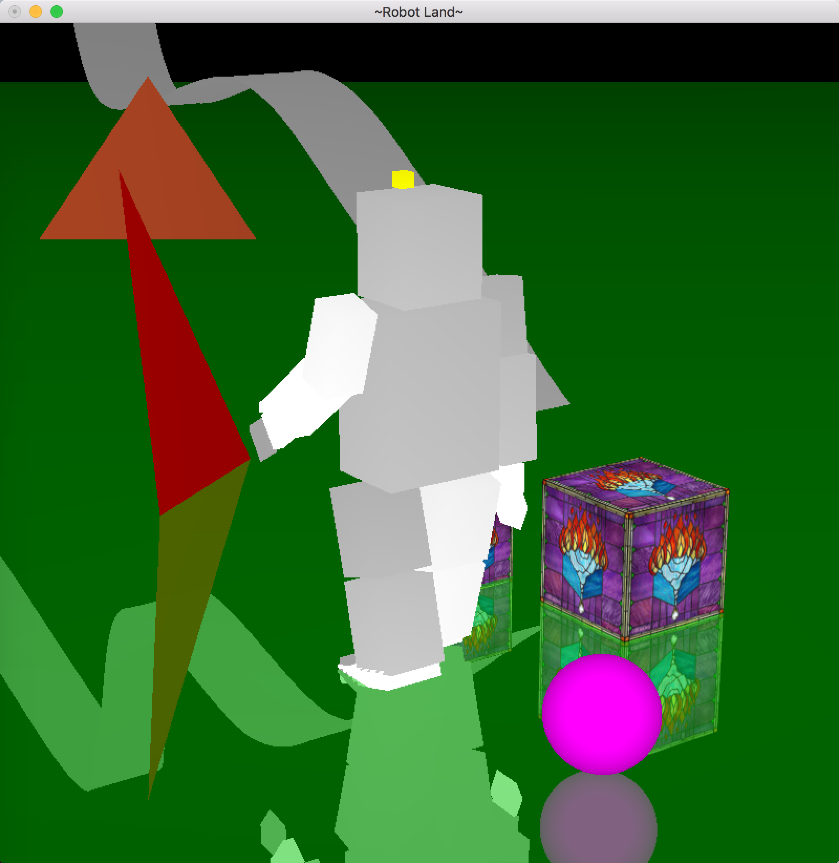

1. Menu to toggle lights

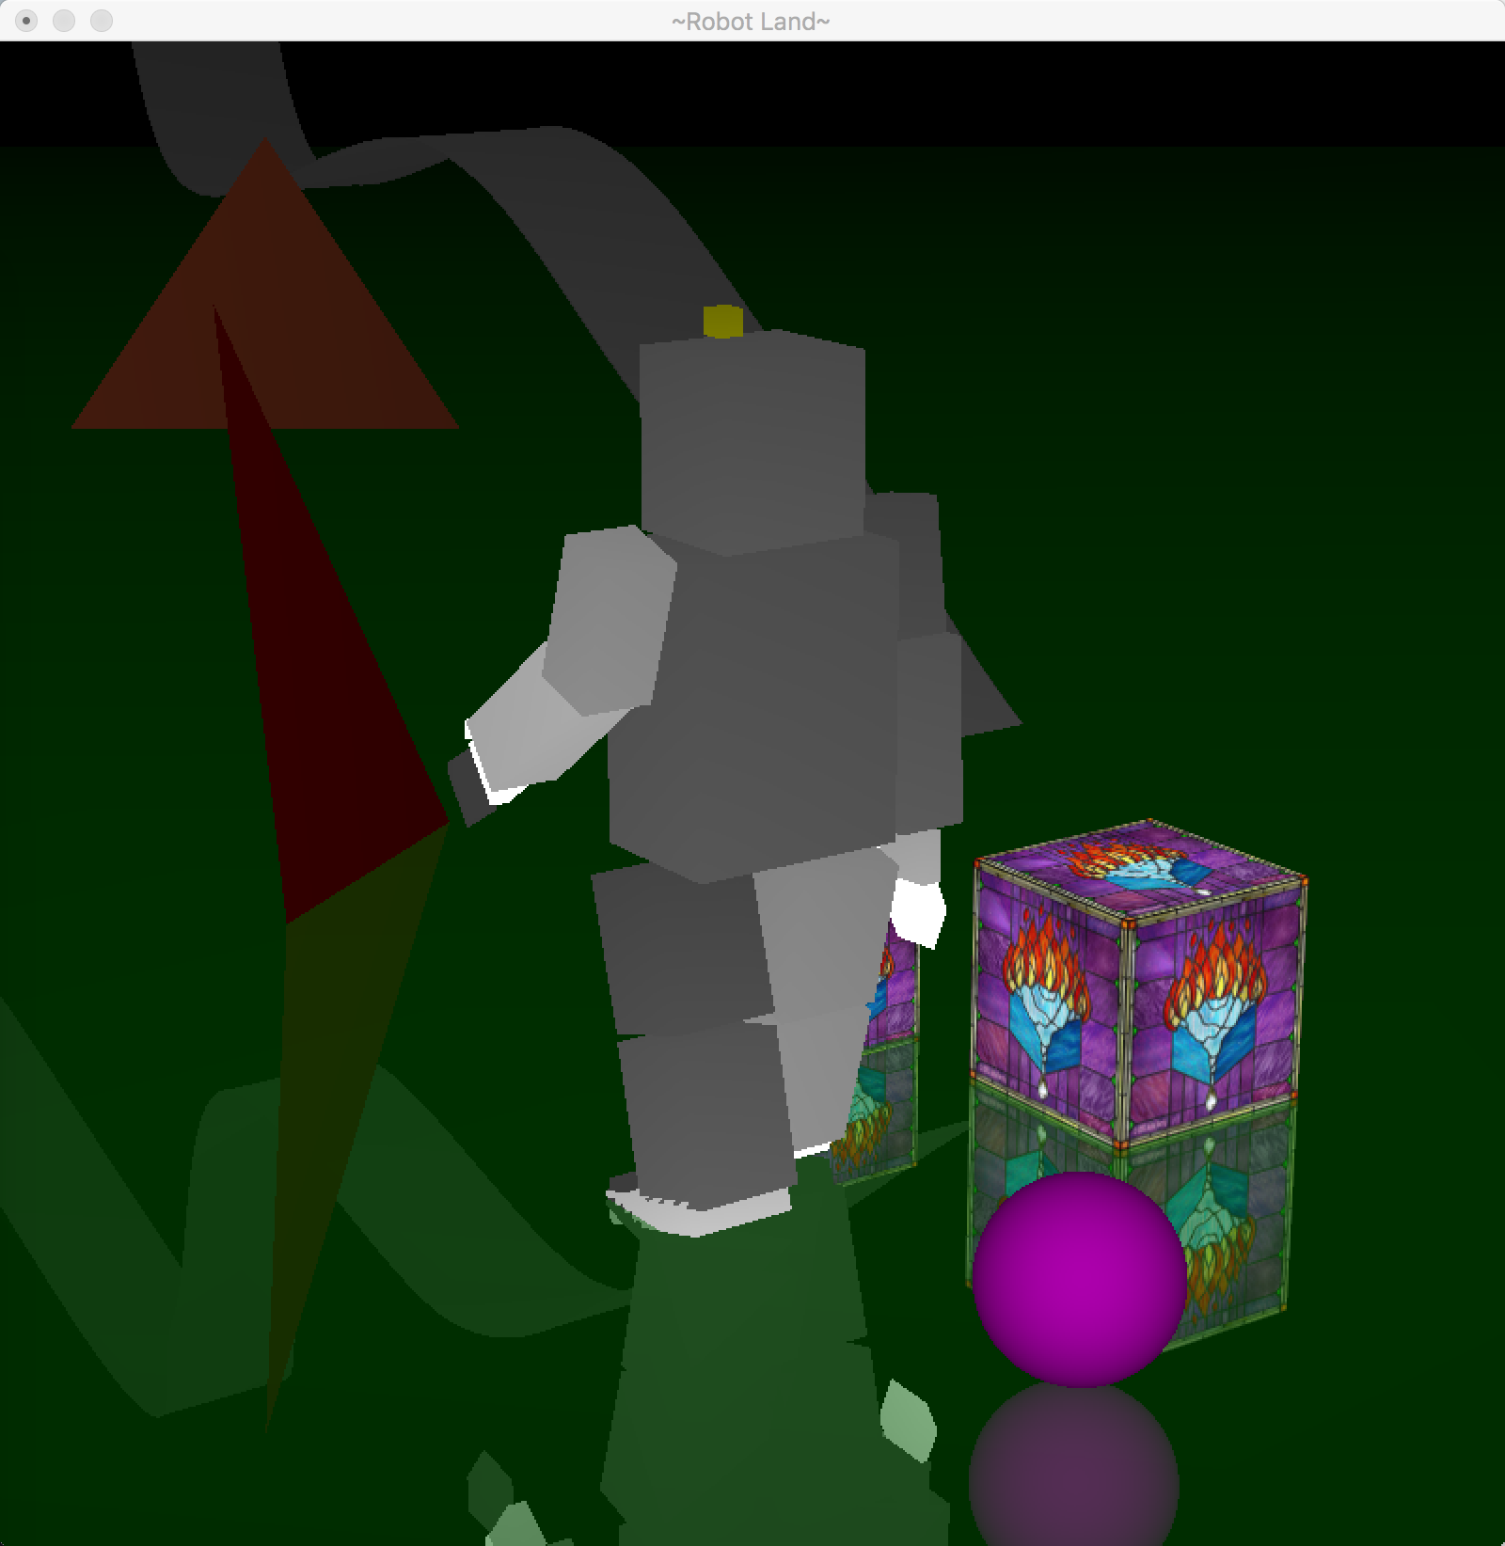

1. Control camera

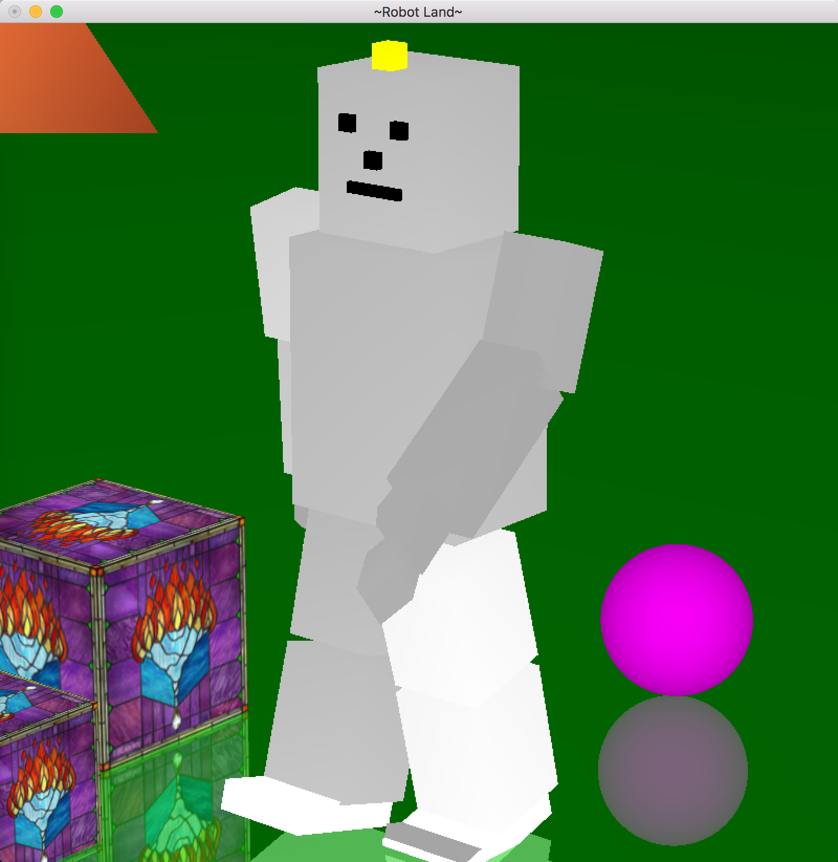

1. Create menu

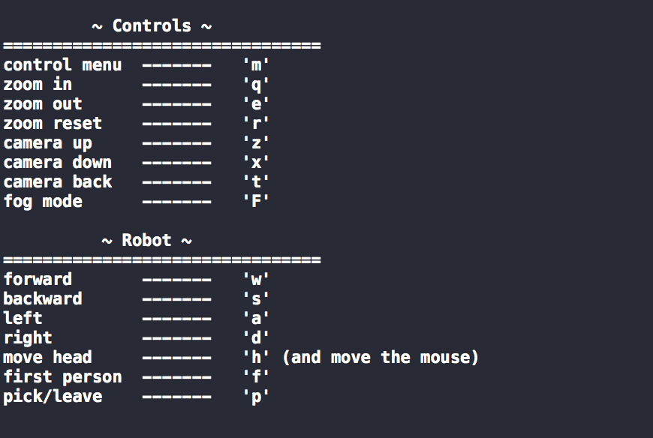

1. Turn head (nods)

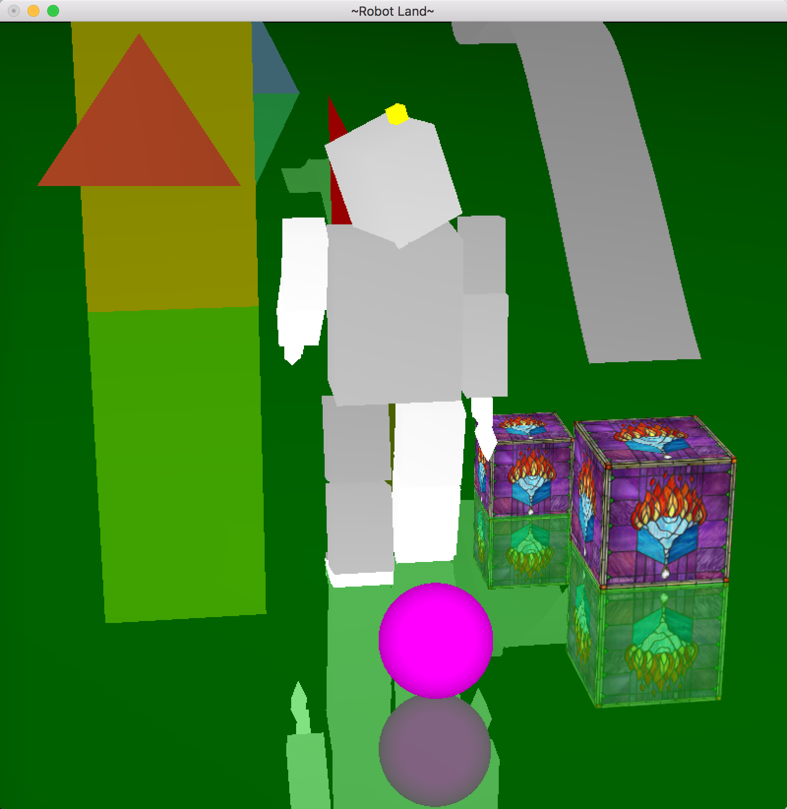

1. Spot light on the head

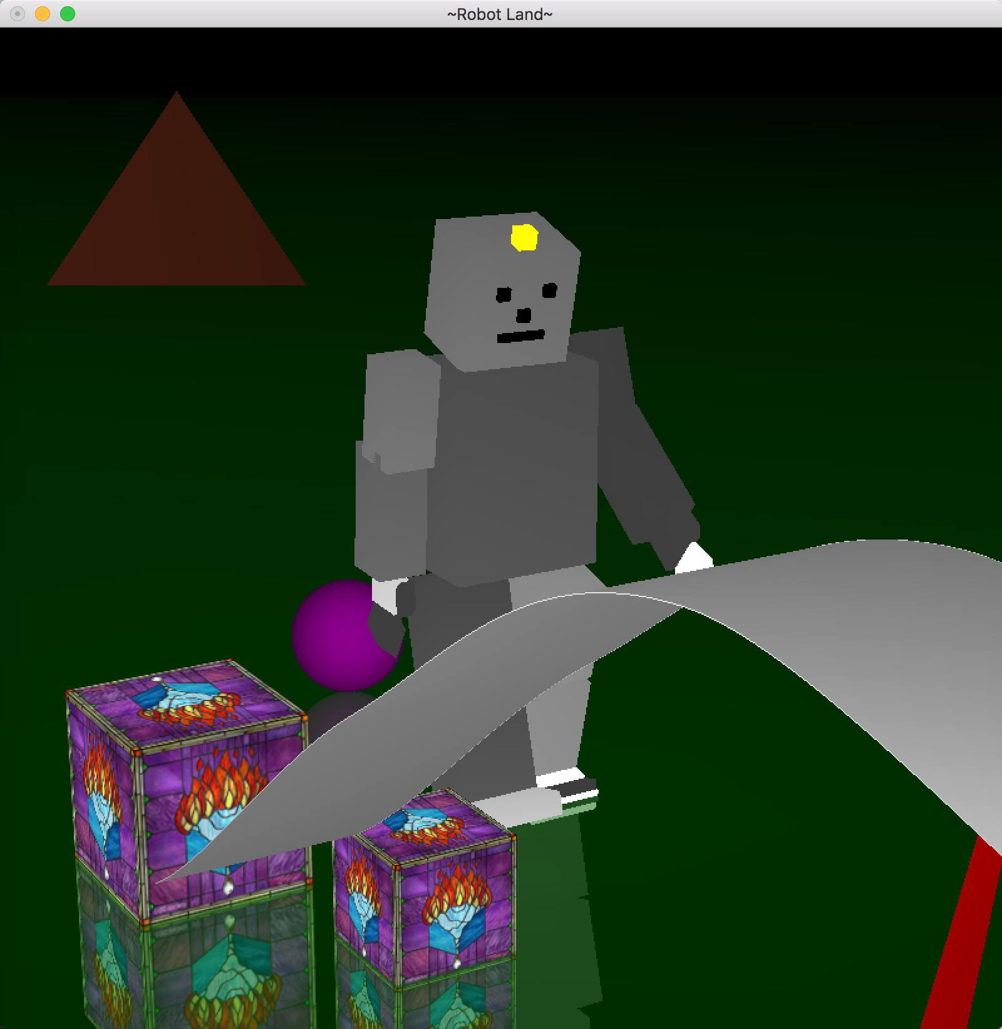

1. Move arms (comparing to the previous plots)

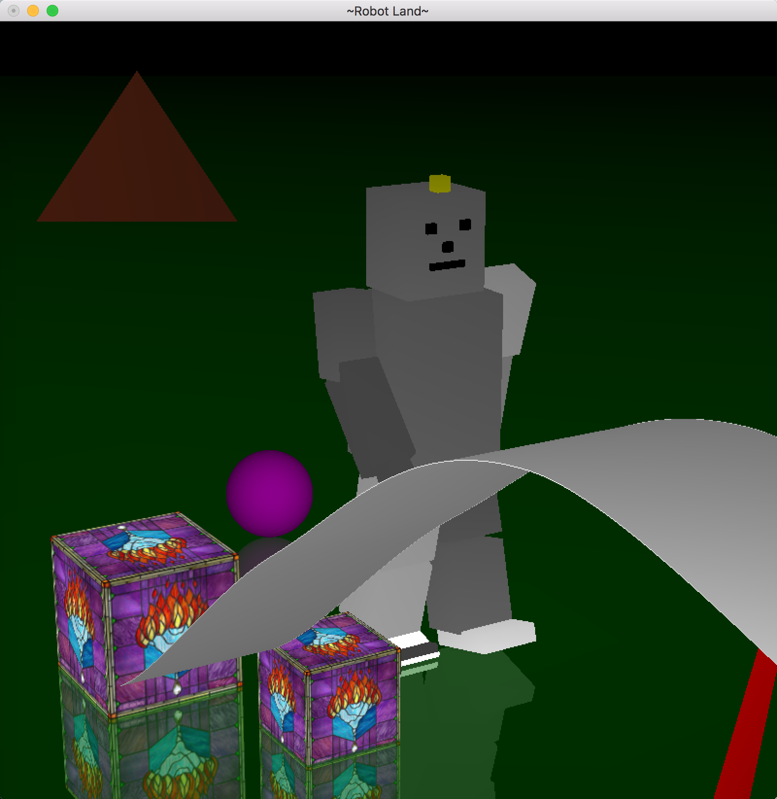

1. Move around the floor

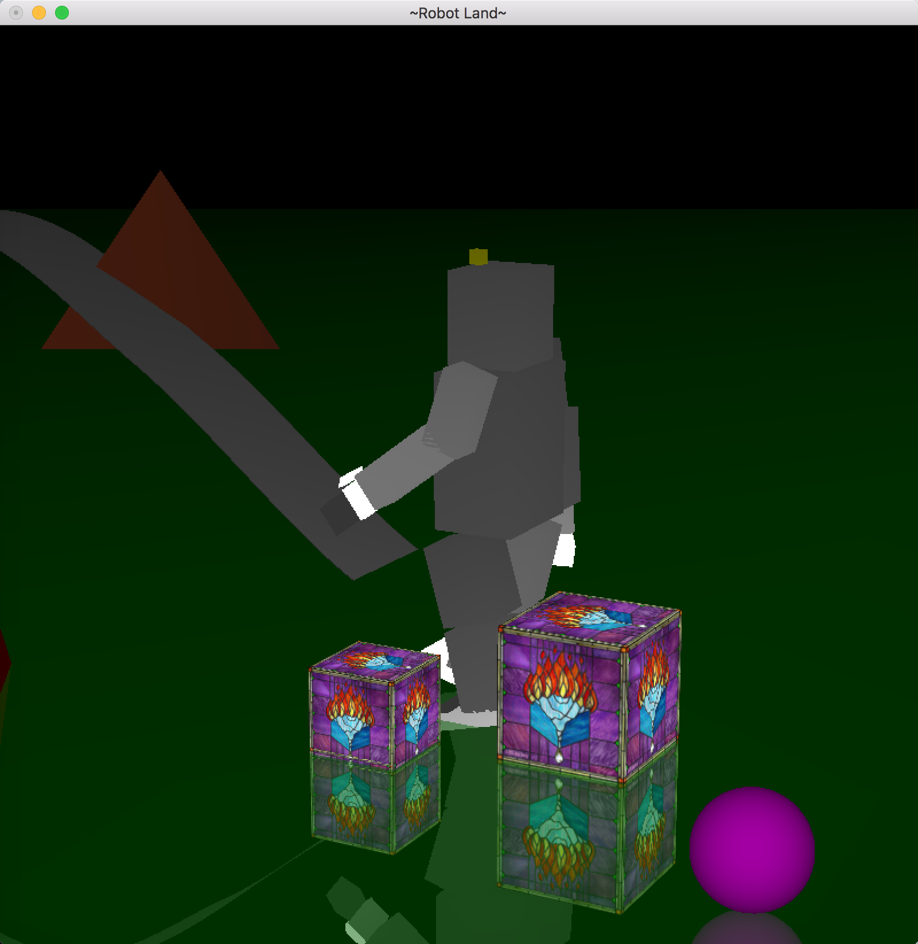

1. Information about the robot control



1. Additional feature (pickable objects)

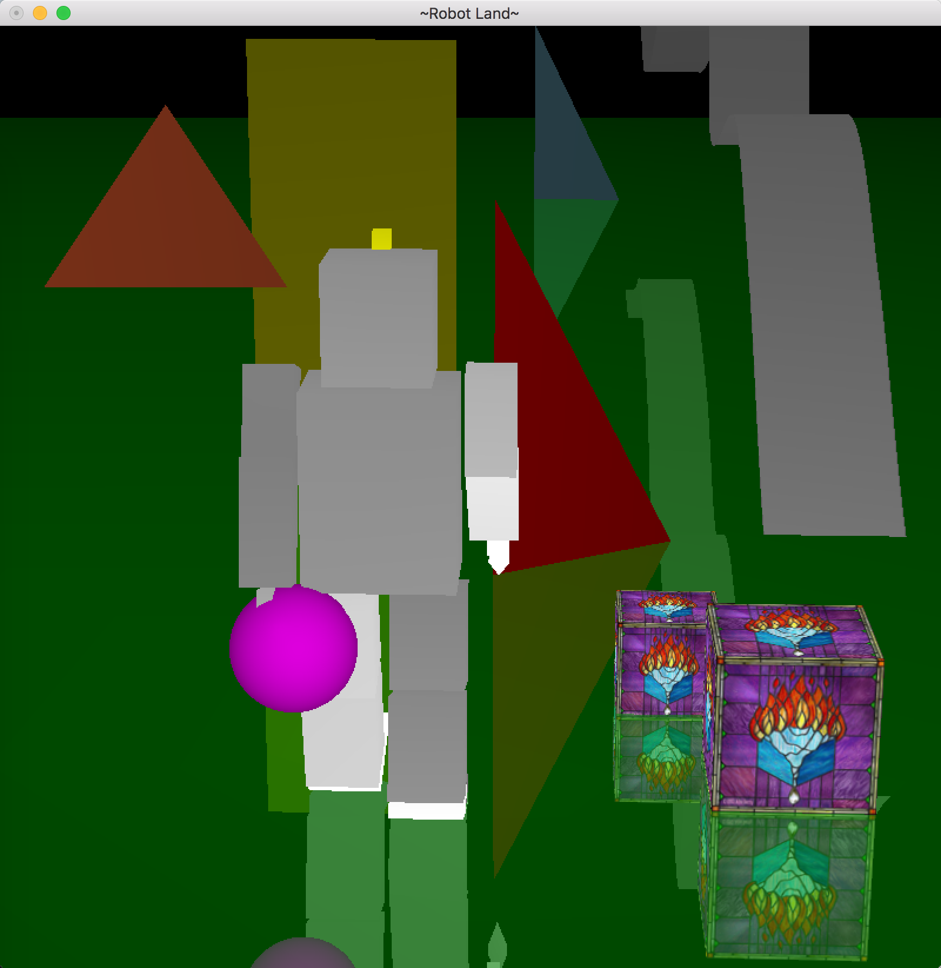

1. Roller Coaster Catmul-rom

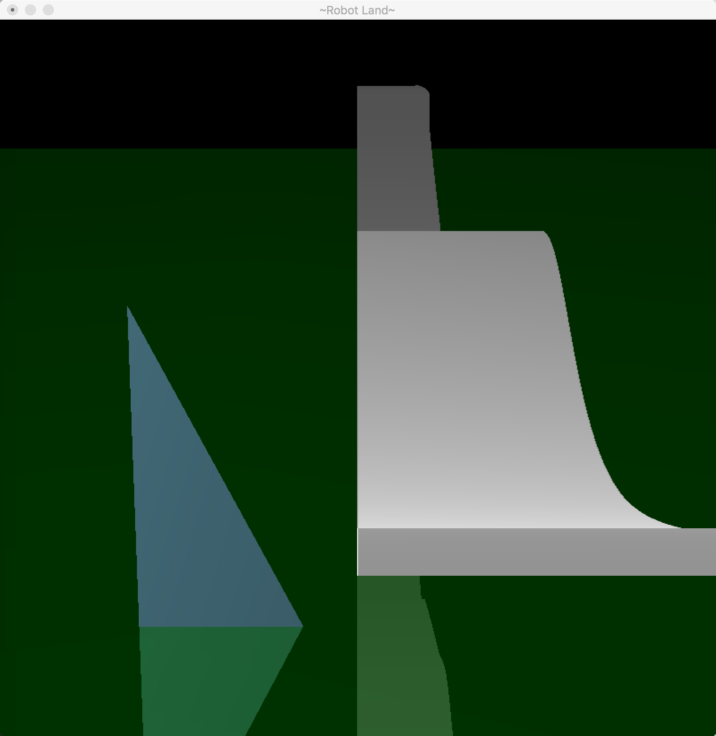

1. Robot trick (stay in the air with a fan)

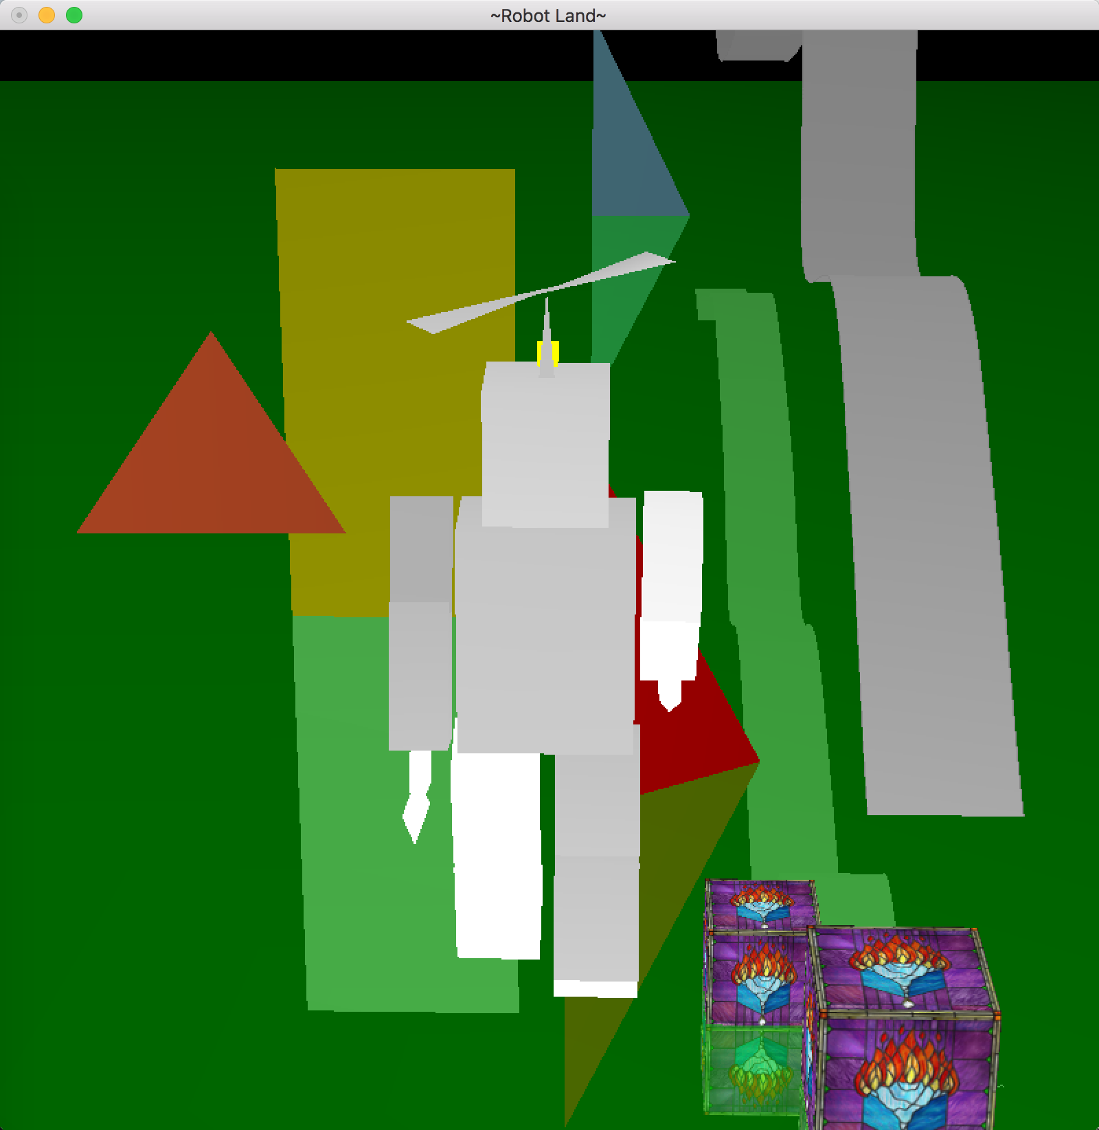

1. Shadow

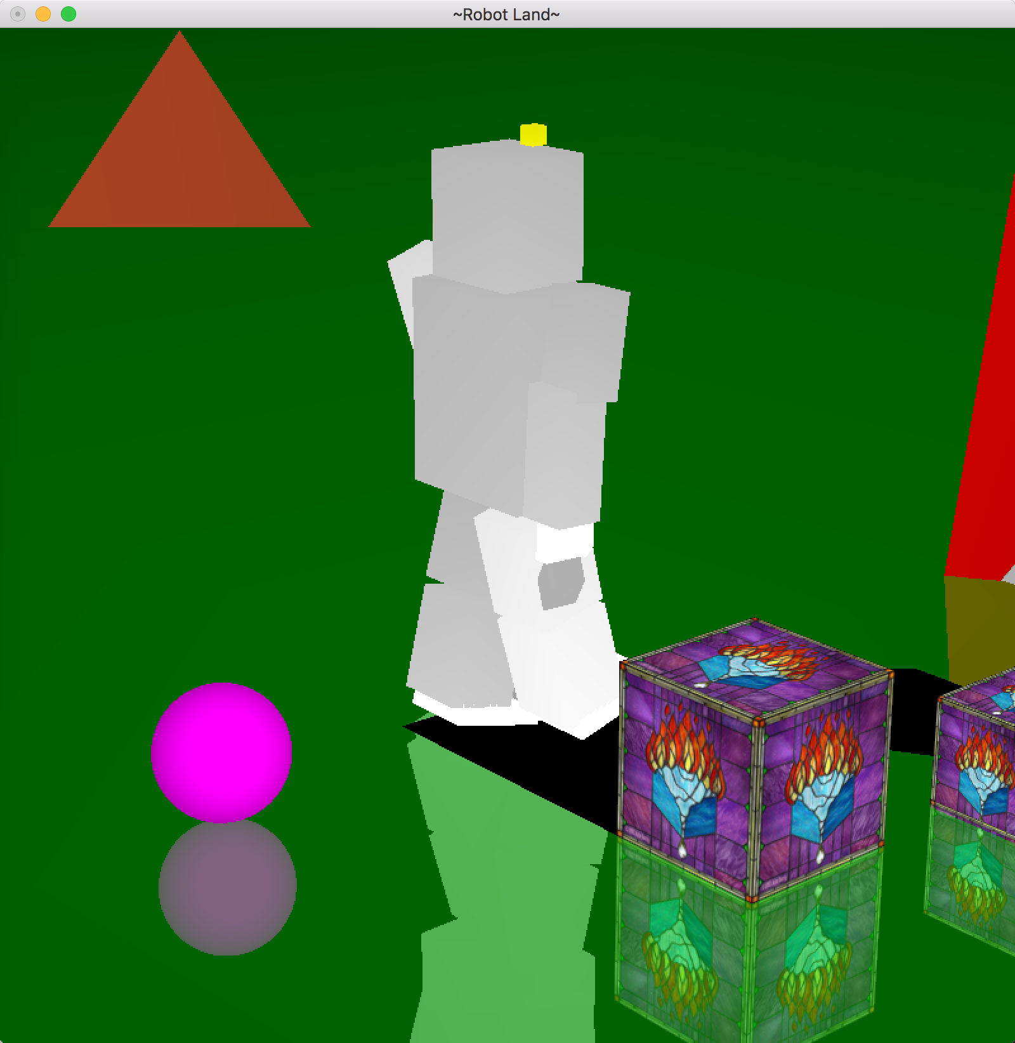

1. Reflections

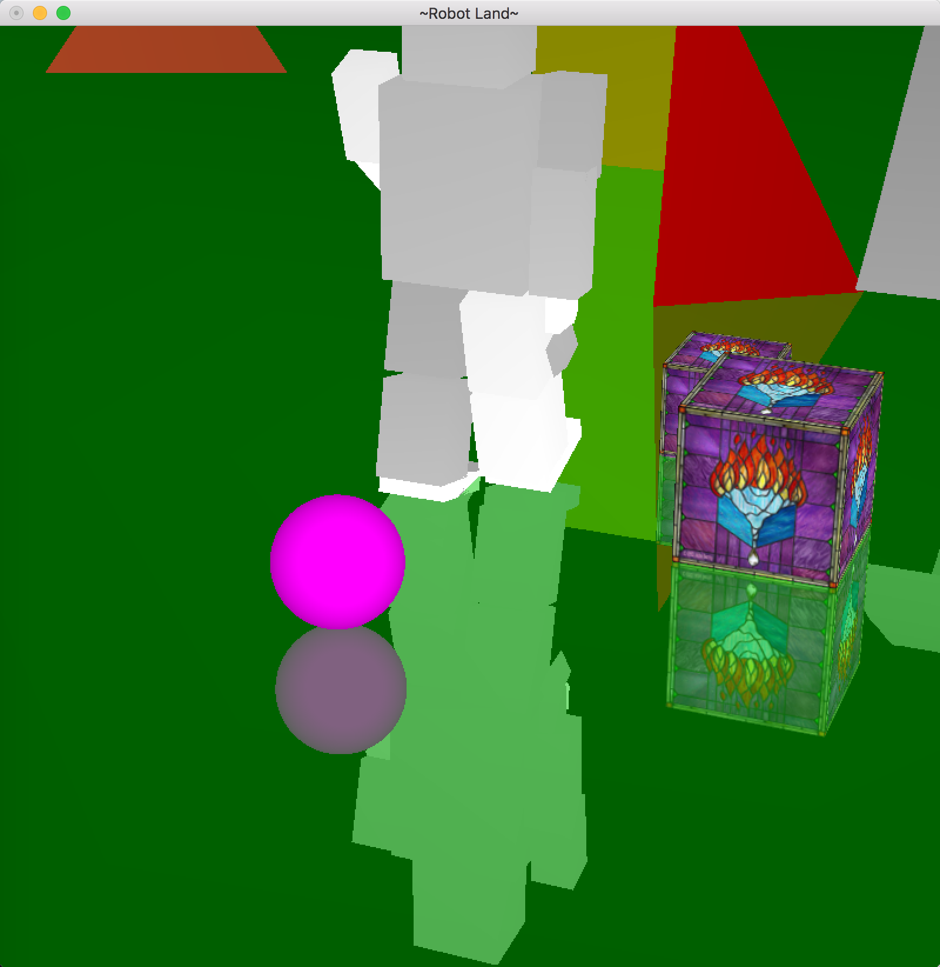

1. Texture mapping

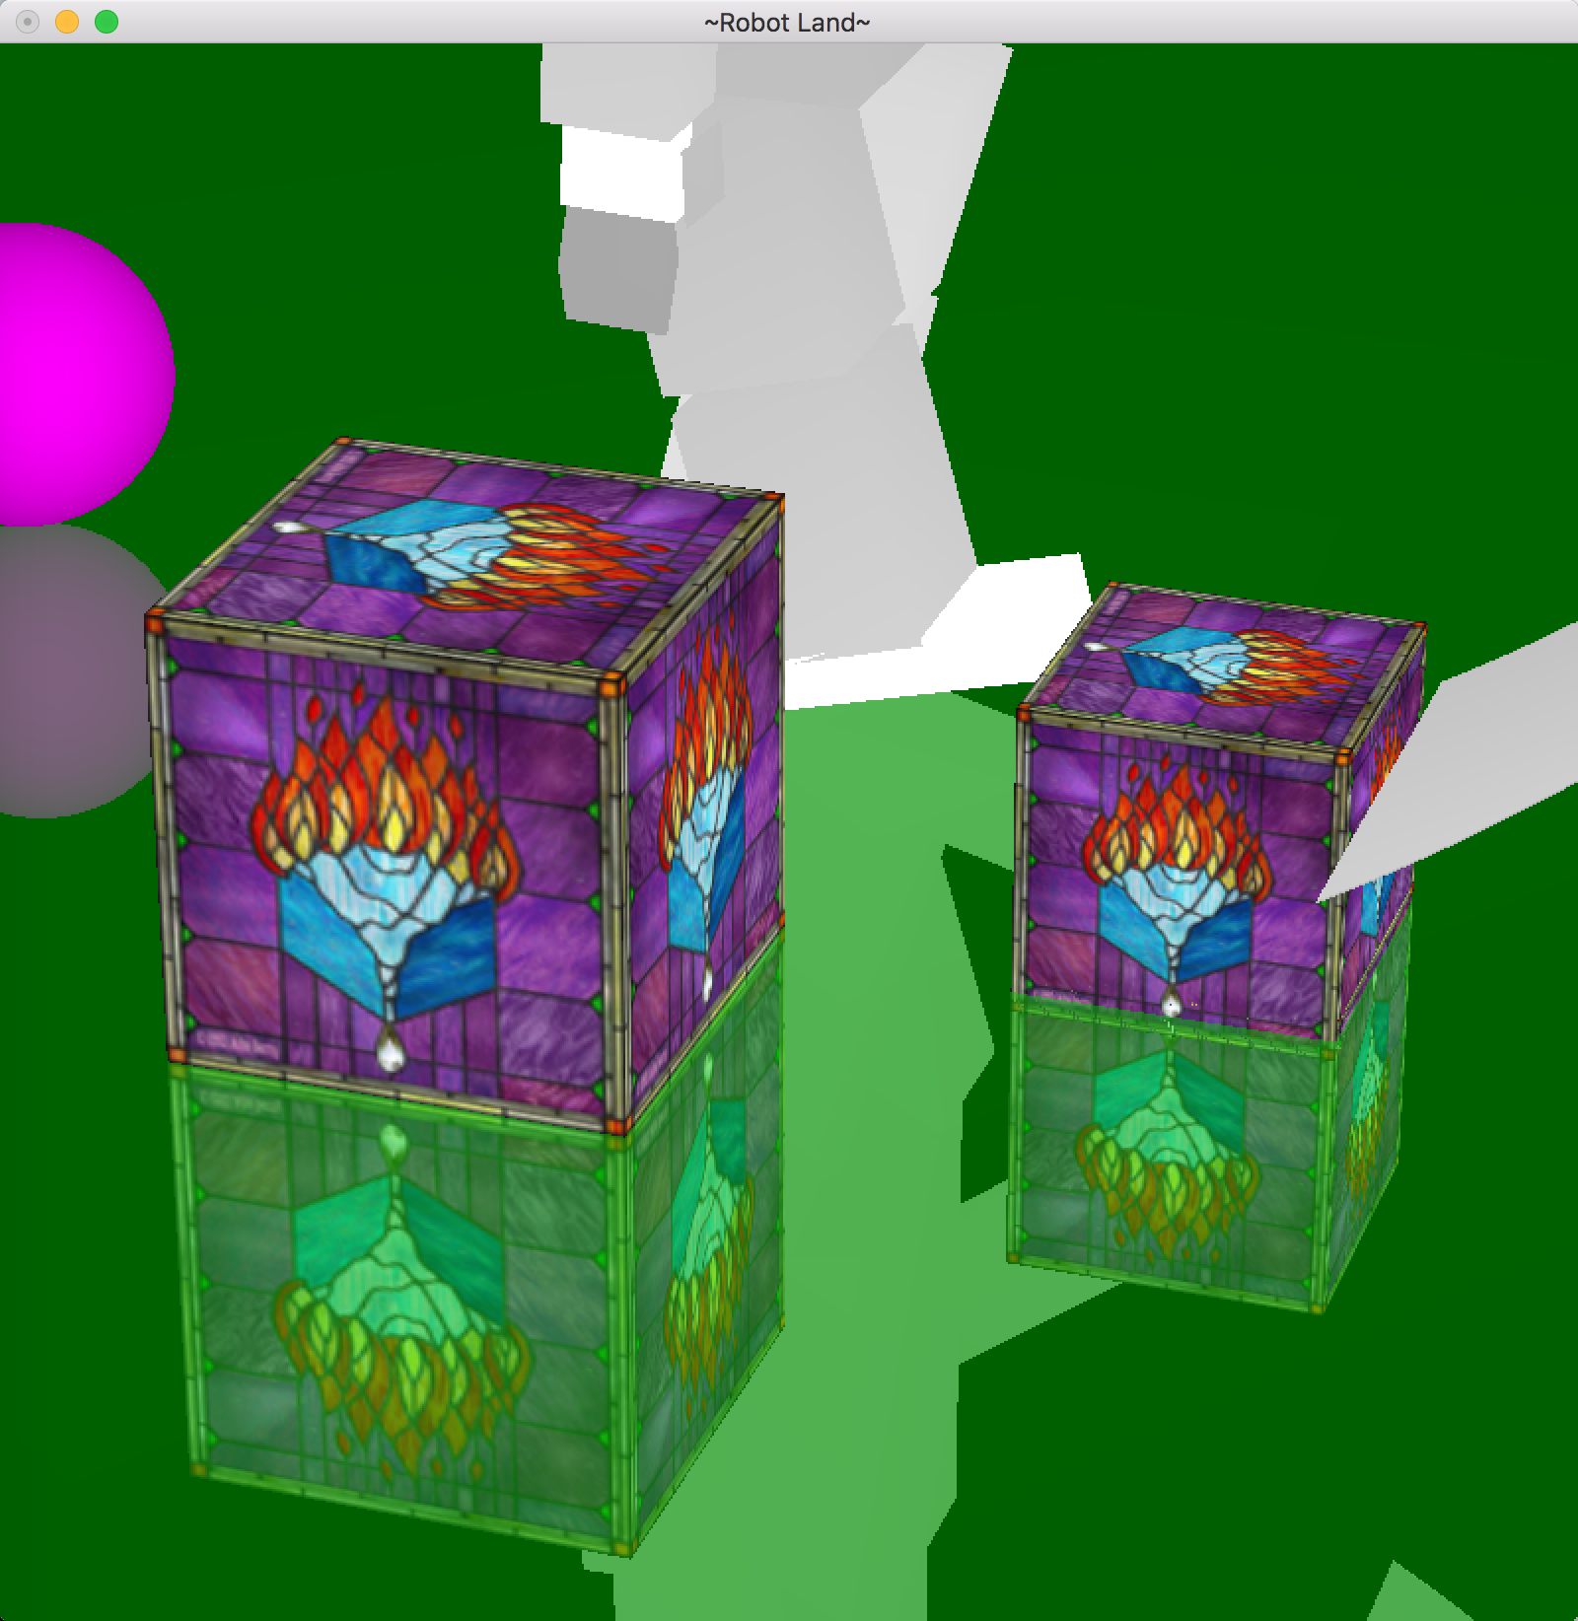

1. Add a mirror

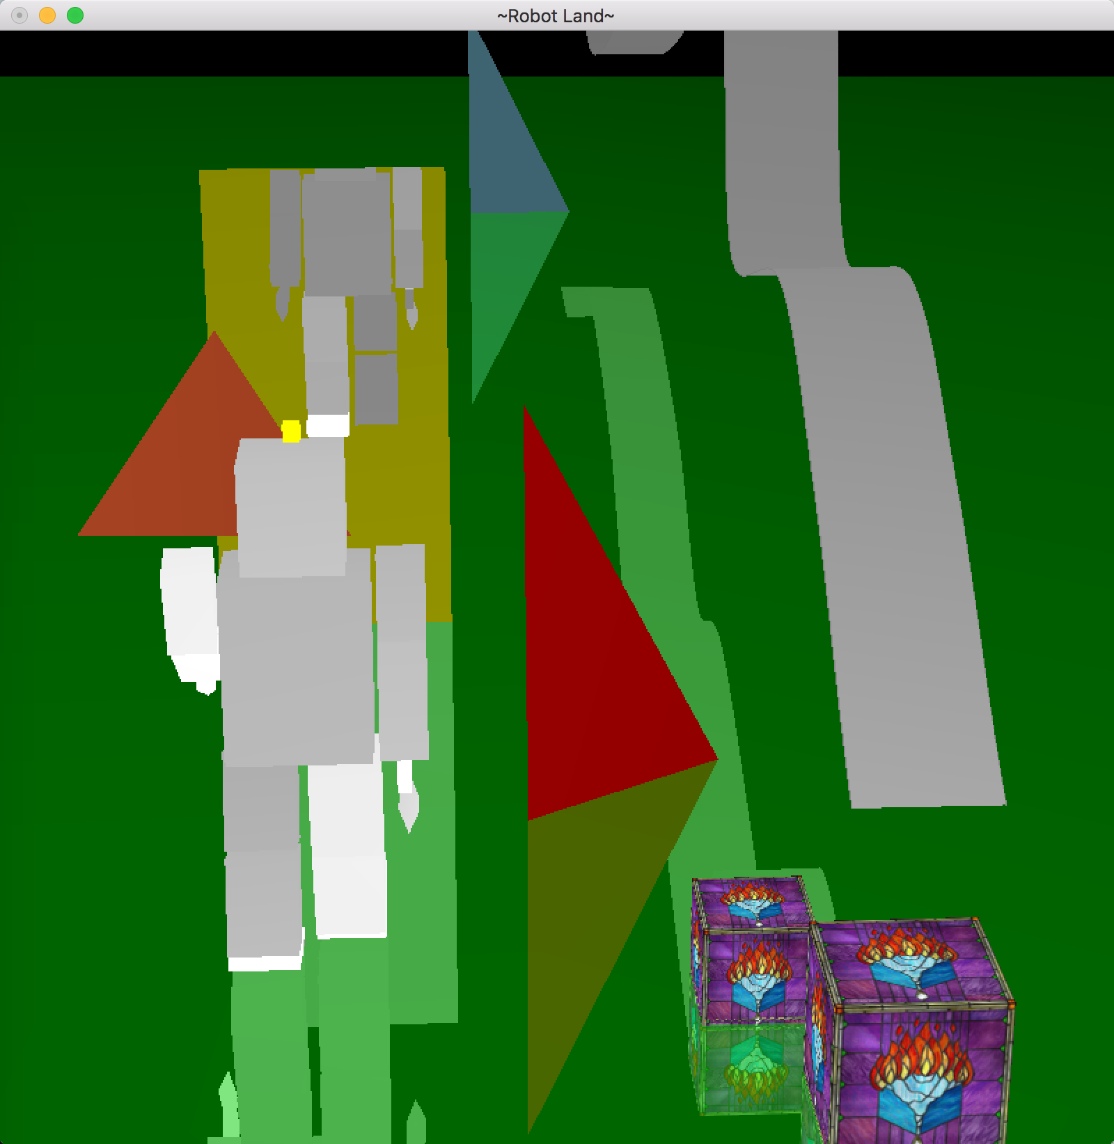

1. Billboard object (triangle)

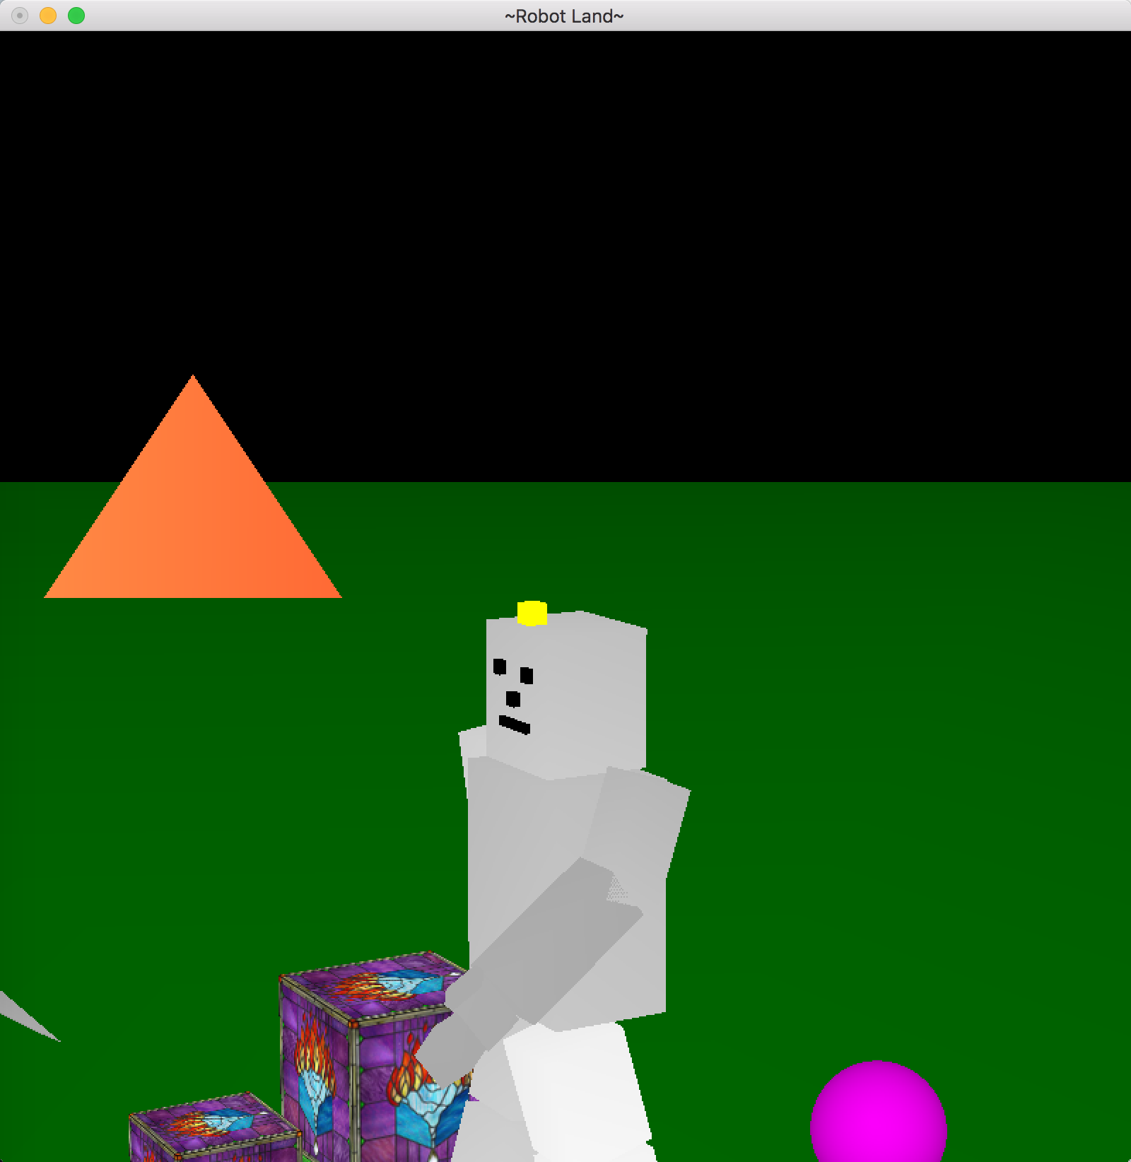

1. Fog effects

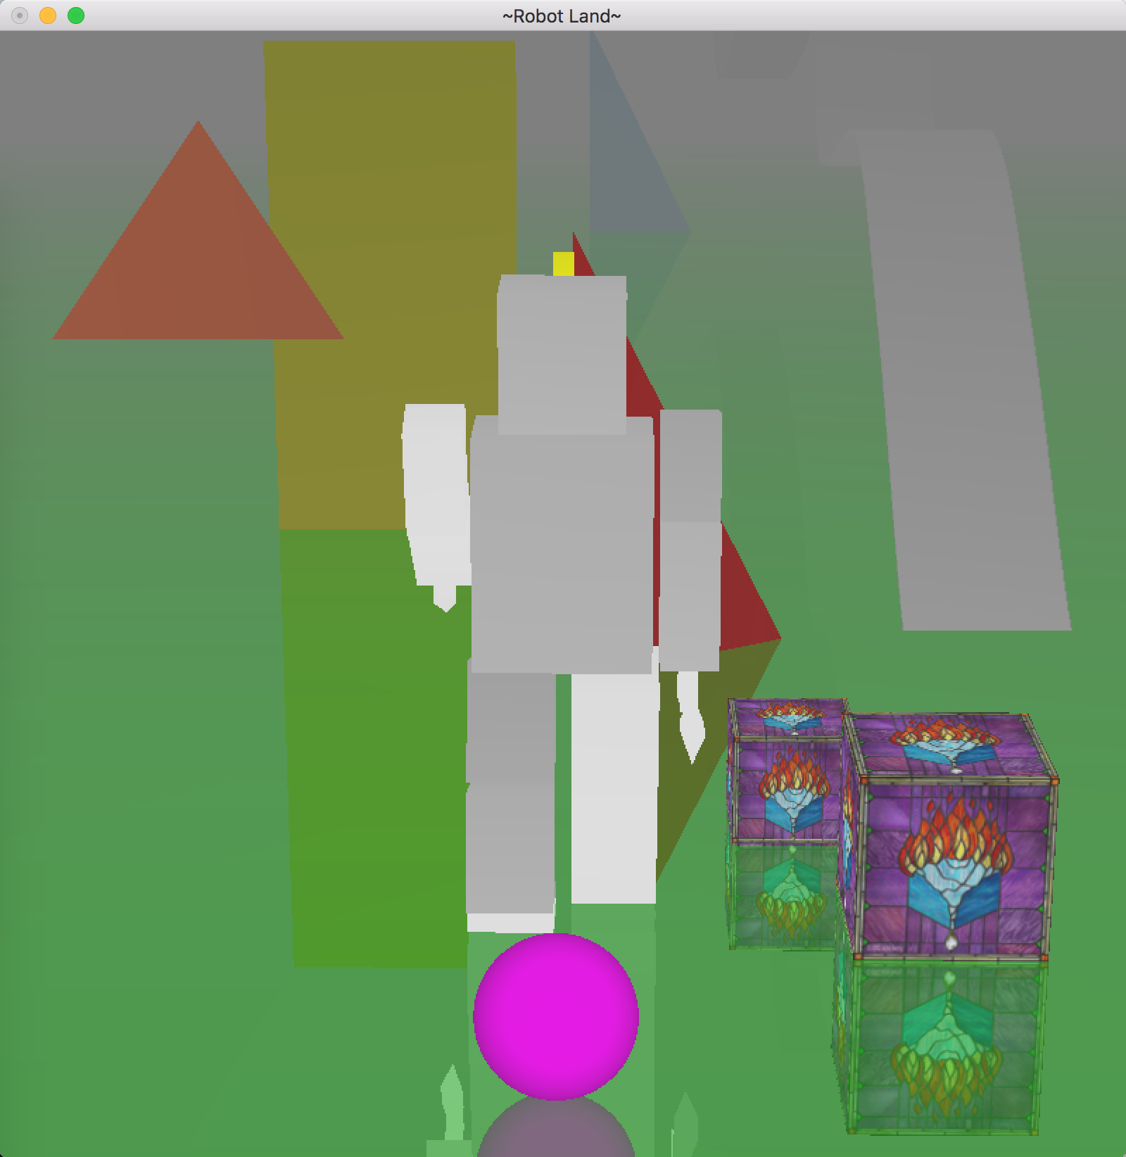

1. Fonts and buttons

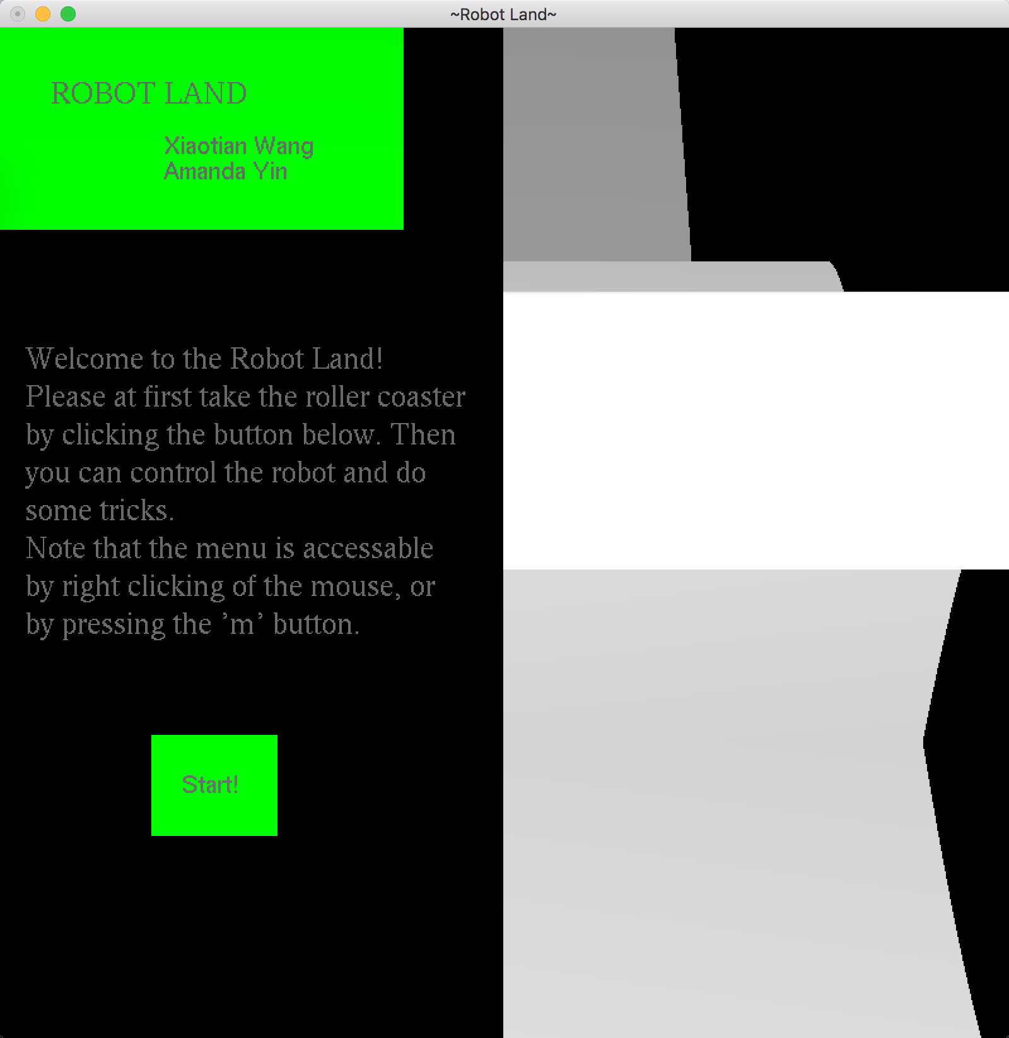

1. Known bugs

There are no known bugs.